Timeline Reconstruction
Flag: PacketCapture{7!m3l1n3_15_4_l13}
Category: Forensics (network / crypto)
Tools used: Python (scapy, pycryptodome, numpy), hashlib
Steps:
1. Start point: trace.pcap.
- What I found: 704 packets, all DNS over UDP/53 between 10.0.15.42 and 10.0.0.2. Almost every query is ordinary traffic (alpinelinux.org, pypi.org, api.github.com, cdn.discordapp.com, s3.amazonaws.com, updates.microsoft.com), all answered with 192.168.1.50.
- Odd ones out: four TXT queries to frag-<32 hex chars>.telemetry.internal-cloud.net, each sent only once and never answered.
- Thinking: a 32-character hex label is exactly 16 bytes, which is one AES block. These are the "hidden fragment left behind by the intruder", smuggled out through DNS.
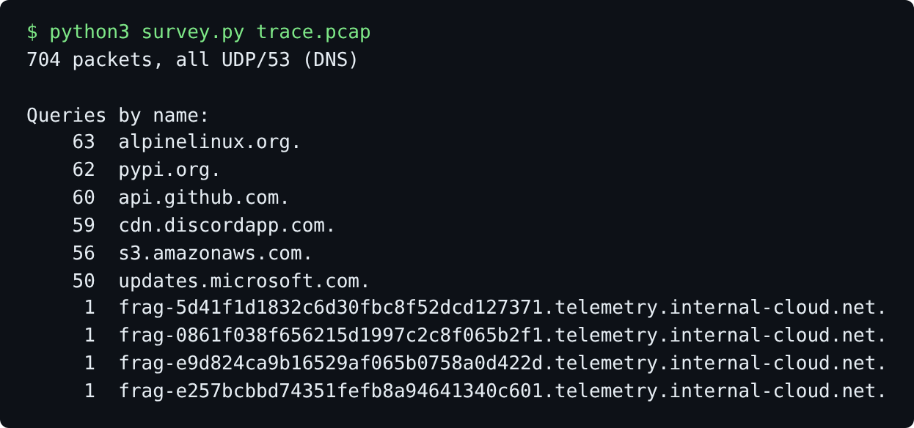
Query names in the capture; the four frag- lookups stand out
2. Pivot: the "corrupted timeline".
- What I did: listed the four fragment packets with their timestamps and DNS transaction IDs (TXIDs).
- Result: normal traffic ends about 894 s into the capture, but the fragments appear 2,170 s to 55,250 s in, hours after everything else. They are the "blocks of activity outside the flow of time".
- Thinking: the timestamps can't be trusted for ordering. The hint says the TXIDs are "connected to a deterministic sequence", so the TXIDs hold the real order.
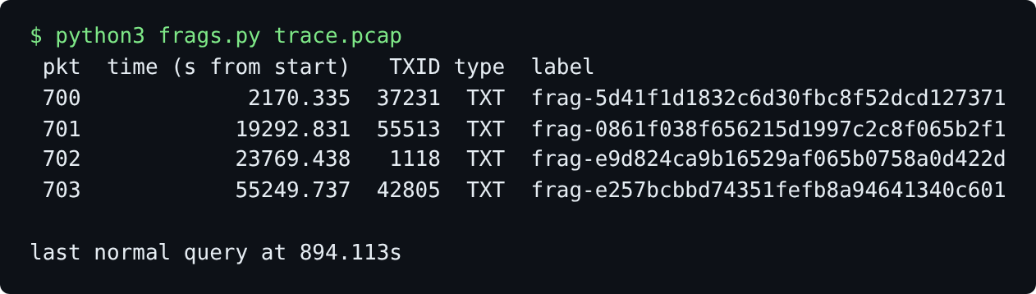
The four fragments, their timestamps and TXIDs
3. Dead end: the normal traffic TXIDs.
- What I tried: treating all 350 normal query TXIDs as a 16-bit LCG (both in packet order and as a shuffled set), plus the standard unknown-modulus LCG crack.
- Result: nothing. Those TXIDs are just random noise meant to hide the pattern.
4. Pivot: cracking the LCG on the fragment TXIDs.
- Thinking: a 16-bit TXID is often the top half of a 32-bit LCG state (like C rand()). So for each fragment TXID I fixed the top 16 bits, brute-forced the low 16 bits, and stepped common LCG constants forward to see whether the other fragment TXIDs came out.
- Result: the Numerical Recipes LCG (a = 1664525, c = 1013904223, m = 2^32, TXID = state >> 16) produces all four TXIDs back to back: 42805, 37231, 1118, 55513. Stepping one state backwards gives the seed 13377331 ("1337 7331"), which is clearly placed on purpose.
- Thinking: the real order is the LCG order (42805 > 37231 > 1118 > 55513), not the time order (37231 > 55513 > 1118 > 42805). Each fragment also has its own LCG state, which is what the keys must be built from.
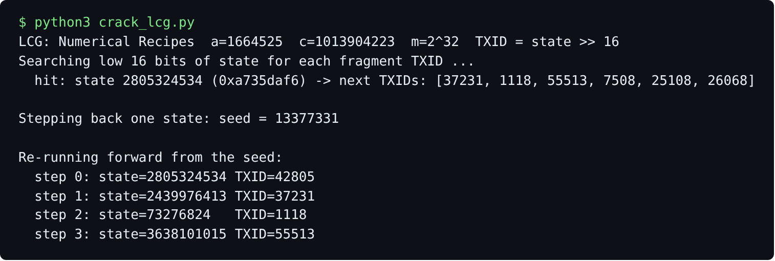
The LCG hit, the recovered seed, and the four states
5. Pivot: deriving each AES key and IV.
- Problem: the challenge doesn't say how a key and IV come from the LCG state. Raw LCG output bytes (every byte position and endianness), AES-192/256, and other modes (CTR, CFB, OFB) all gave garbage.
- What I did: built a big list of candidate 16-byte values per fragment (hashes of the state, TXID, seed and index as strings and packed integers, zero-padded and to_bytes() forms) and tried every key x IV pair, scoring the decrypted text for printable characters across all four fragments.
- Result: one pair clearly won. Key = first 16 bytes of SHA-256(str(state)), IV = state.to_bytes(16, "little"), AES-128-CBC with PKCS#7 padding. Each fragment decrypts to 8 readable characters plus 8 bytes of padding.
- Thinking: an early near-miss printed "PacketCa88888888pture{7!..." The repeating 8s were the 0x08 padding bytes XORed with "0" characters from a wrong IV guess. That showed the key was already right and only the IV's upper half was off.
6. Decrypt and concatenate.
- What I did: reran the LCG from the seed, derived the key and IV from each state, decrypted the matching fragment, stripped the padding and joined the pieces in LCG order.
- Result: PacketCa + pture{7! + m3l1n3_1 + 5_4_l13} = PacketCapture{7!m3l1n3_15_4_l13} ("the timeline is a lie").
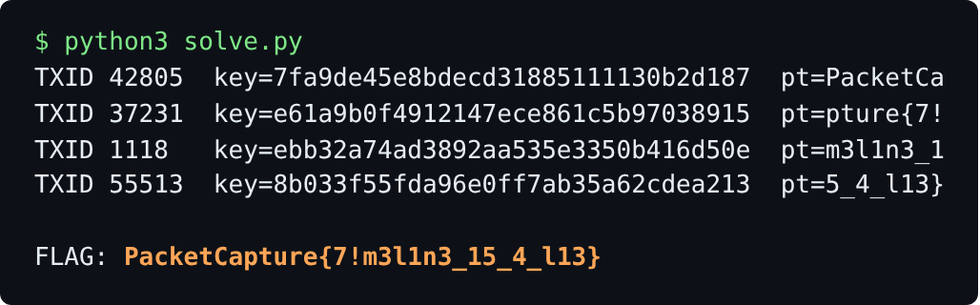
Final solve script output
Key insight: The timestamps are the deception and the TXIDs are the truth. Packet times put the fragments in the wrong order, while the LCG behind the TXIDs gives both the correct order and the per-fragment state that the AES keys come from. The noisy normal traffic exists to hide that the only TXIDs following the sequence are the four fragments'.

